**Test for Javascript**

Code:

string="Javascript Land...\nHappy Coding!"

alert(string)

output:

Code:

var n="Jhone Doe"

alert("Name: " + n)

var age=15

alert(age + " years old")

var string="Certified Mobile Developer"

alert(string);

Output:

Code:

var email;

email="omershahzad1010@gmail.com"

string="My email address is: " + email;

alert(string);

Output:

Code:

document.write("Yah! I can write HTML through Javascript.")

Output:

Code:

var age=23;

string="i am " + age + " years old.";

alert(string);

Output:

Code

var birthyear=2002;

string="Data Type of my declared variable is: "+ typeof birthyear;

document.write("My Birth Year is: " + birthyear + "<br>" )

document.write(string);

Output:

Code:

document.write("<h1>Rules for naming JS Variables:</h1>")

document.write("<p>Variables can only contain alphabets,numerics,symbols and characters</p><br>")

document.write("<p>For example $my_1stVariable.</p><br>")

document.write("<p>Variables must begin with a alphabet or symbol For example $name, _name or name</p><br>")

document.write("<p>Variable names are case Sensitive</p><br>")

document.write("<p>Variable names should not be JS keywords</p><br>")

Output:

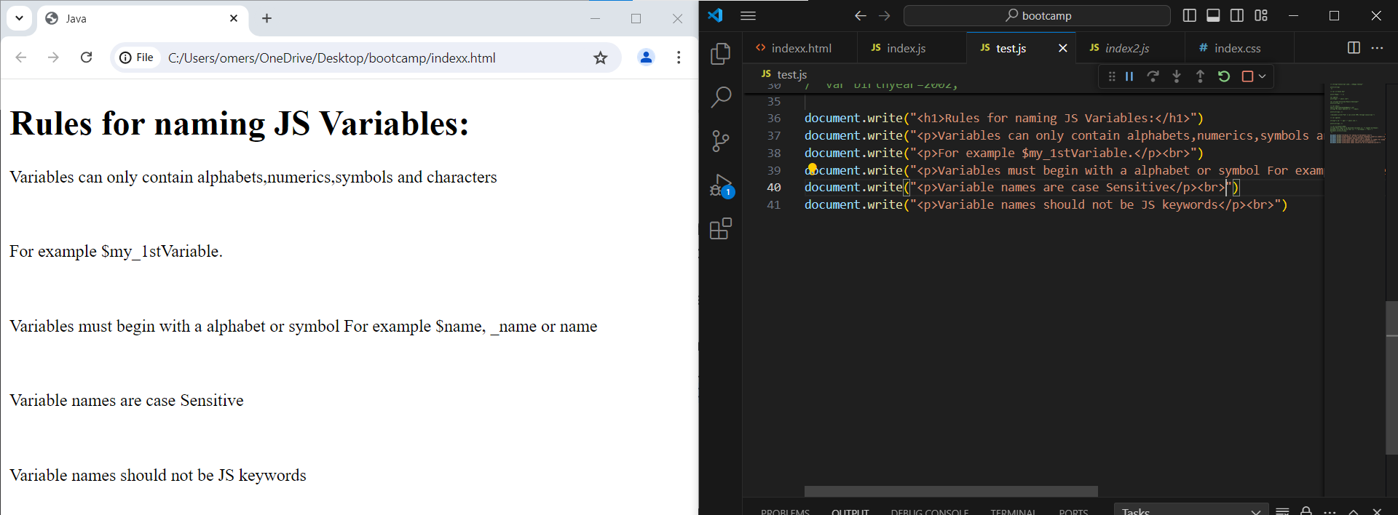

Code:

a=3;

b=5;

sum=a+b;

document.write("Sum of " + a + " and "+ b + " is: " + sum)

Output:

Code:

a=3;

b=5;

sum=a+b;

sub=a-b;

mul=a*b;

div=a/b;

modu=a%b;

document.write("Sum of " + a + " and "+ b + " is: " + sum + "<br>")

document.write("Subtraction of " + a + " and "+ b + " is: " + sub + "<br>")

document.write("Multiplication of " + a + " and "+ b + " is: " + mul + "<br>")

document.write("Division of " + a + " and "+ b + " is: " + div + "<br>")

document.write("Modulus of " + a + " and "+ b + " is: " + modu + "<br>")

Output:

Code:

var a;

type= typeof a;

document.write(a);

a=5;

document.write("The Initial Value of a is: " + a+ "<br>");

a=++a;

document.write("The Value after Increment of a is: " + a + "<br>");

a=a+7;

document.write("The Value after Adding 7 in a is: " + a + "<br>");

a=--a;

document.write("The Value after Decrement of a is: " + a + "<br>");

a=a%3

document.write("The Current Value (Remainder) of a is: " + a + "<br>");

Output:

Code:

var celcius=25;

var faren=70;

celformula=(faren-32)*5/9;

farenformula=(celcius*9/5)+32;

document.write(celcius + "C is " + farenformula + "F"+ "<br>")

document.write(faren + "F is " + celformula+ "C" + "<br>")

Output:

Code:

document.write("<h1>Currency in PKR</h1> <br>");

document.write("Total Currency in PKR: 1748 <br>")

Output:

Code:

let a = 10;

document.write("The value of a is:" + a + "<br>");

document.write("...................................<br>");

document.write("The value of ++a is:" +  ++a+ "<br>");

document.write("Now the value of a is:" + a+ "<br>"+ "<br>");

document.write("The value of a++ is:" + a+++ "<br>");

document.write("Now the value of a is:" + a+ "<br>"+ "<br>");

document.write("The value of --a is:" + --a+ "<br>");

document.write("Now the value of a is:" + a+ "<br>"+ "<br>");

document.write("The value of a-- is:" + a--+ "<br>");

document.write("Now the value of a is:" + a+ "<br>"+ "<br>");

Output:

Code:

var a = 2, b = 1;

var result = --a - --b + ++b + b--;

document.write(--a+ "<br>");

document.write(--a - --b+ "<br>");

document.write(--a - --b + ++b+ "<br>");

document.write(--a - --b + ++b + b--+ "<br>");

Output:

